Excel Assignment – 18

1. What are comments and what is the importance if commenting in any
code?
Comments are lines in a code file that are not executed. They are used to explain the code, making it easier to understand for others (or yourself in the future).
Importance of comments in any code:
- Code readability: Helps others understand the purpose and logic of the code.
- Debugging aid: Explains why certain decisions were made, aiding in troubleshooting.
- Collaboration: Facilitates teamwork by documenting the intent behind the code.
- Maintenance: Makes it easier to update or modify the code later.

2. What is Call Statement and when do you use this statement?
In Excel, a Call Statement is used in VBA (Visual Basic for Applications) to execute a procedure or subroutine.
Syntax: Call ProcedureName
You use it to call a specific Sub procedure within VBA code, making the code modular and reusable.
Sub MainProcedure()
Call SubProcedure
End Sub

Sub SubProcedure()
MsgBox "Hello from SubProcedure!"
End Sub

3. How do you compile a code in VBA? What are some of the problem that
you might face when you don’t compile a code?
How to Compile Code in VBA:
- Open the VBA Editor (Alt + F11).
- Go to the Debug menu.
4.Select Compile VBAProject.
Problems If You Don’t Compile:
- Syntax Errors: Undetected until runtime, causing code crashes.
- Logical Bugs: Harder to trace as uncompiled code skips error-checking.
- Performance Issues: Code may run slower due to unresolved inefficiencies.
- Incomplete Execution: Errors during runtime can halt the program unexpectedly.
Compiling helps ensure the code is error-free and ready for execution.

- What are hot keys in VBA? How can you create your own hot keys?
Hotkeys in VBA
Hotkeys are keyboard shortcuts that trigger specific macros or functions in Excel.
Creating Your Own Hotkeys
- Open the VBA Editor (Alt + F11) and write a macro.
- In Excel, go to Developer > Macros.
- Select your macro and click Options.
- Assign a shortcut key (e.g., Ctrl + Shift + M).
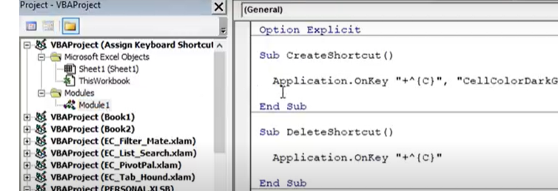

5. Create a macro and shortcut key to find the square root of the following
numbers 665, 89, 72, 86, 48, 32, 569, 7521
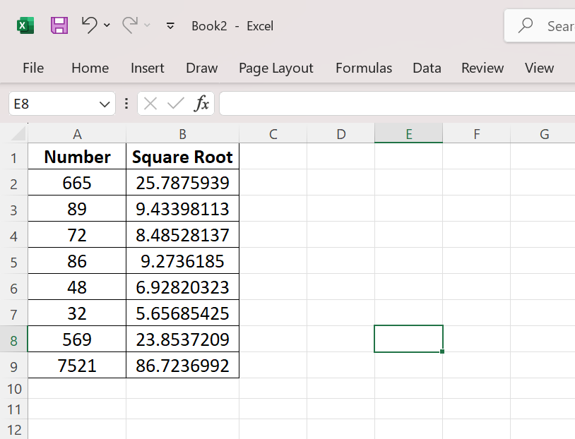

6.What are the shortcut keys used to
Here are the shortcut keys commonly used in the VBA Editor for debugging and running code:
- Run the code
Shortcut: F5
This runs the code until it completes or encounters a breakpoint.
- Step into the code
Step Into the Code
Shortcut: F8
This executes the code line by line, allowing you to follow the flow of execution in detail.
- Step out of code
Shortcut: Shift + F8
This allows you to step out of the current procedure and continue execution.

- Reset the code
Shortcut: Ctrl + Break
This stops the running code and resets the VBA environment. Alternatively, you can click the Reset (Stop) button (a square icon) in the toolbar.
These shortcuts are essential for efficiently debugging and testing your VBA code.

